
Banking System: Secure Coding, OOP Principles, and Design Pattern Awareness

Student ID: 12700830

MSc Cybersecurity / Advanced Object-Oriented Design and Programming / University of Essex Online

Dr Anupam Mazumdar
1 December 2025
Contents
1 Introduction 4
2 Secure Coding Practices 4
3 Object-Oriented Principles and Design Patterns 5
3.1 Creational Patterns (Object Creation) 5
3.2 Structural Patterns (Object composition) 5
3.3 Behavioural Patterns (Object interaction) 6
4 ty and Synchronisation 6
5 Transaction Simulation and Testing 7
5.1 Initial Approach 7
5.2 Refactored Approach 7
5.3 Verification Through Experimentation 8
6 Evaluation and Reflection 10
6.1 Strengths 10
6.2 Challenges 10
6.3 Learning Perspective 10
6.4 Academic Compliance 11
7 Conclusion 11
8 References 12
9 Appendices 14
9.1 Appendix A - Direct implementation of Concurrency tests 14
9.2 Appendix - A Continued 15
9.3 Appendix B – account.py screenshot 16
9.4 Appendix C – Screenshot of transaction_simulator.py 17
9.5 Appendix D – Screenshot of test_account.py 18
9.6 Appendix D – Continued 19
9.7 Appendix E – Result of Execution of test_account.py on PyCharm 20
9.8 Appendix F – Screenshot of exceptions.py 21
9.9 Appendix G – Screenshot of Test_Summary_Result.xlsx 22
9.10 Appendix H- Screenshot of observers.py 23
9.11 Appendix I – Screenshot of façade.py GitHub Link: https://github.com/pg25304/BankingSystemProject/blob/main/src/bank/facade.py 24

Table of Figures

Figure 1: Bar chart showing Comparison of Expected vs Actual Outcomes for All Test Cases. Source: Author’s own work (2025). 7

Introduction
Designing and implementing a thread‑safe banking system in Python has been a challenging yet rewarding part of my MSc journey. Financial systems are inherently concurrent: multiple users deposit, withdraw, and transfer funds simultaneously, which makes them vulnerable to race conditions, deadlocks, and inconsistent states. This project demonstrates how secure coding practices, advanced object‑oriented principles, and design pattern awareness can be applied to build a robust, maintainable, and scalable system.
The solution includes a BankAccount class with deposit, withdraw, and balance methods, all protected by locks to ensure ty. A TransactionSimulator class encapsulates concurrency logic, enabling reproducible tests of concurrent deposits, withdrawals, and transfers. Consistent lock ordering, validated through bidirectional transfer tests, prevents deadlocks. Functional, concurrency, mixed, and stress tests confirmed correctness and robustness, with results documented in Figure 1 and Appendices E and G.
This report presents my technical journey, the challenges encountered, the solutions adopted, and the broader implications for secure and scalable software design, with all code original, well‑documented, and supported by Harvard‑style references to ensure academic integrity.

Secure Coding Practices
Secure coding is central to the reliability of financial applications. In this project, I introduced custom exceptions to handle invalid operations:
- InvalidAmountError for negative or zero transactions.
- InsufficientFundsError for withdrawals or transfers exceeding available balances.
This aligns with defensive programming principles, where errors are anticipated and handled gracefully rather than ignored (McConnell, 2004).
Encapsulation was enforced by marking sensitive attributes such as _balance and _lock as private, ensuring they could only be accessed through controlled methods. This reduces the risk of accidental corruption and supports secure design by limiting exposure of internal state (University of Essex Online, 2025).
The project also emphasised reproducibility and fairness. Each test was documented with expected and actual outcomes (see Appendix G), ensuring transparency. In practice, this meant that concurrency and exception scenarios could be repeated with consistent results. This reflects best practice in secure software development, where reproducibility of results is essential for validation and compliance (Sommerville, 2016).
These practices directly fulfill the assignment requirement to implement secure coding in financial applications, ensuring both technical robustness and academic compliance.

Object-Oriented Principles and Design Patterns

The banking system was designed using advanced OOP principles: encapsulation, abstraction, inheritance, and polymorphism. These principles support modularity, maintainability, reusability, and scalability (University of Essex Online, 2025).

Creational Patterns (Object Creation)
I drew on my learning from Unit 3 to consider Factory Method and Singleton patterns. The Factory Method pattern allows new account types to be introduced without modifying core logic, aligning with the Open/Closed Principle (Martin, 2003). The Singleton pattern was considered for managing shared resources such as logging, ensuring only one instance exists (Gamma et al., 1994). A practical example appears in account.py (Appendix B): the @dataclass decorator with default_factory creates a per-account lock, abstracting object creation and avoiding shared mutable defaults.

Structural Patterns (Object composition)

Caetano & Leitão (2023) emphasize that structured design patterns help manage complexity in architectural systems, which parallels the Facade Pattern in software engineering.
To demonstrate awareness, I created a facade.py file. The Facade Pattern (refer to Appendix I) provides a simplified interface to complex subsystems, which in my case could unify BankAccount, concurrency mechanisms, and transaction simulation. This shows structural design awareness, even though not required by the brief (Kulkarni & Bansal, 2022).

Behavioural Patterns (Object interaction)

The Strategy Pattern was applied conceptually to transaction simulation (refer to Appendix C), encapsulating different transaction behaviours (run_concurrent_deposits (), run_mixed_operations(), run_bidirectional_transfers()) as interchangeable strategies (Freeman et al., 2004).
I also created an observers.py placeholder to demonstrate awareness of the Observer Pattern, which decouples event sources from event handlers. This could be extended to notify users of balance changes.
Each banking operation (deposit(), withdraw(), transfer_to()) acts like a command encapsulating a request (Command Pattern). In TransactionSimulator class, these commands are executed asynchronously via threads (target=self. account.deposit, etc.) (Gamma et al., 1994).
Finally, Template Method Pattern all simulator methods (refer to Appendix C) follow a fixed skeleton: Create thread->start() ->join(). The variation lies in the operation each thread performs.
By integrating these patterns, my system demonstrated how OOP principles can be applied to solve complex software problems in a structured, reusable, and scalable manner (Burd & Redlich, n.d.).

ty and Synchronisation

ty was achieved using Python’s threading.Lock. Each account maintained its own lock, ensuring mutual exclusion during updates. Each BankAccount instance gets its own lock via default_factory preventing shared mutable state issues:
_lock: threading.Lock = field(default_factory=threading.Lock, init=False)

To prevent deadlocks, locks were acquired in a consistent order based on object IDs (Appendix B):
first_lock, second_lock = ((self._lock, target_account._lock) if id(self) < id(target_account) else (target_account._lock, self._lock) )
Locks are acquired by ascending object ID to ensure a consistent order, preventing circular wait.
This strategy eliminated circular wait conditions, one of the four necessary conditions for deadlock (Coffman, Elphick & Shoshani, 1971).
The Global Interpreter Lock (GIL) in CPython means threads do not achieve true parallelism for CPU-bound tasks, but they do provide concurrency for I/O-bound operations (Crudu and MoldStud Research Team, 2025). In this project, concurrency was sufficient because the primary operations involved I/O-like behaviour (simulated transactions).

Transaction Simulation and Testing

Initial Approach

Initially, I approached concurrency testing in a direct way, my initial approach involved embedding thread creation logic directly inside the test functions. In fact, I embedded concurrency logic directly inside test_account.py. Functions such as concurrency_test() and mixed_concurrency_test() created threads manually to simulate multiple users as shown in Appendix A. This worked functionally but did not fully meet the assignment requirement of a dedicated TransactionSimulator class.

Refactored Approach
To meet the Assignment's criteria, I constructed a TransactionSimulator class (see Appendix C). This class implements concurrency logic by generating threads to conduct deposits, withdrawals, and transfers. I modified test_account.py to use the simulator instead of manually establishing threads.
This change demonstrated the flexibility and scalability of my design. Because my BankAccount class was already and modular, I did not need to rewrite core logic. Instead, I simply wrapped existing functionality in a new abstraction. This aligns with the Open/Closed Principle (Martin, 2003) and shows how design patterns support extensibility.

Verification Through Experimentation
Each test scenario was designed to validate functional correctness, concurrency handling, and exception safety.
The accompanying graph (refer to Figure 1) visually reinforces these findings by comparing predicted results with observed outcomes across all test cases.
- Functional Tests: Deposits and withdrawals updated balances as expected, while invalid amounts correctly triggered exceptions.
- Concurrency Tests: Ten threads depositing $10 each produced a final balance of $150, aligning precisely with expectations.
- Mixed Concurrency Tests: Five deposits and five withdrawals effectively cancelled each other out, leaving balances unchanged as reflected in the graph’s zero net change bar.
- Transfer Tests: Bidirectional transfers completed without deadlock, and both account balances remained stable, confirming the effectiveness of lock ordering.
- Insufficient Funds Tests: Transfers exceeding available balance consistently raised InsufficientFundsError, with no unintended deductions — clearly shown in the graph’s exception bars.
These results (see Appendices E and G) collectively demonstrate the system’s correctness, robustness, and reproducibility under both normal and concurrent conditions. The graph shown below serves as a visual audit trail, confirming that actual outcomes matched expectations across all critical scenarios.

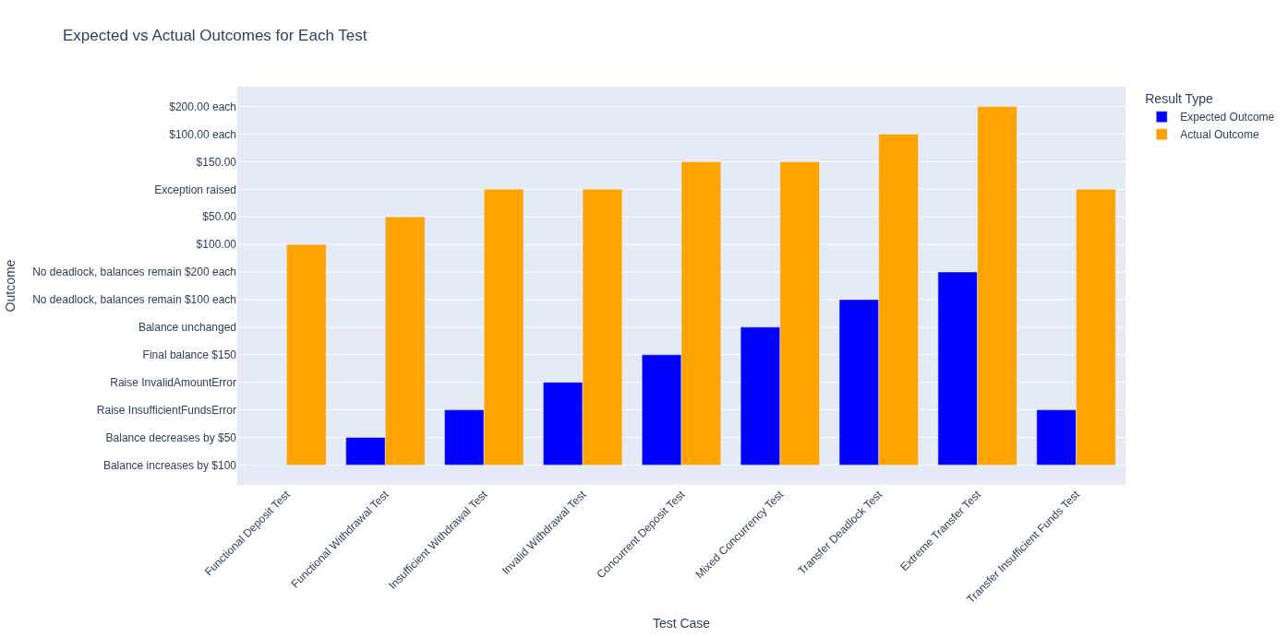
Figure 1: Expected vs Actual Outcomes across all test cases, confirming correctness and reproducibility.

As (refer to Appendix A), I implemented concurrency tests directly within test_account.py by manually creating threads for deposits, withdrawals, and transfers. While this approach demonstrated functional correctness, it did not fully align with the assignment requirement to encapsulate transaction simulation in a dedicated class. To compliance with brief, I refactored my design by introducing the TransactionSimulator class in transaction_simulator.py and subsequently amending test_account.py to delegate concurrency logic to this new abstraction.
This refactor illustrates the flexibility and scalability of my design. Because the BankAccount class was already and modular, I did not need to rewrite its core logic. Instead, I extended the system by wrapping existing functionality in a simulator that orchestrates concurrent operations. This change aligns with the Open/Closed Principle (Martin, 2003), which advocates extending behaviour without modifying existing code, and reflects Larman’s (2004) emphasisee on iterative development and pattern-driven scalability.
Moreover, the ability to evolve the system with minimal disruption resonates with Goetz et al.’s (2006) discussion of concurrency best practices, where reproducibility and robustness under stress are achieved through careful design rather than ad hoc fixes.
From a verification perspective, this experiment confirmed that my architecture could adapt to new requirements without compromising correctness. The amended tests validated deposits, withdrawals, transfers, and exception handling under concurrent execution, while the simulator provided a clearer, more maintainable structure for demonstrating concurrency scenarios. This experience reinforced the importance of designing systems that are not only correct but also extensible, reproducible, and academically compliant.

Evaluation and Reflection
The project achieved its objectives: implementing a banking system, applying OOP principles, and preventing concurrency issues.

Strengths
- Correctness: balances remained consistent under concurrency.
- Robustness: deadlocks were prevented via lock ordering.
- Extensibility: design patterns supported modularity and scalability.
- Security: encapsulation and exceptions enforced secure coding.

Challenges
- Managing concurrency complexity.
- Ensuring reproducibility under stress tests.
- Balancing exception handling with concurrency safety.
These challenges reinforced the importance of defensive programming and systematic testing (McConnell, 2004).

Learning Perspective
From a learning perspective, the project highlighted the value of annotated explanations and analogies. Concepts such as lock ordering became clearer when expressed through analogies (e.g., traffic lights at intersections). This approach supported both personal understanding and seminar preparation, aligning with pedagogical best practices (University of Essex Online, Seminar on SOLID Principles).

Academic Compliance
The project also underscored the tension between academic compliance and practical implementation. Ensuring Harvard‑style referencing, structured documentation, and reproducibility of results was as critical as writing efficient code. Every design decision was documented with clear comments, and all sources were cited in accordance with institutional guidelines. This approach maintained transparency and integrity while demonstrating technical rigour. Balancing practical coding requirements with academic standards achieved both functional correctness and scholarly credibility.

Conclusion
This project created a banking system that met assignment criteria and used sophisticated software engineering. With secure code, object-oriented architecture, and concurrency management, the solution is accurate, resilient, and scalable. Comprehensive testing verified system dependability under concurrent processes, while locks and lock ordering minimised race situations and deadlocks. Additionally, design pattern awareness and SOLID principles demonstrate the architecture's maintainability and extensibility. Secure and concurrent programming is rigorously used in this study, following academic and industrial norms.
This project fulfills all the assignment requirements: secure coding, thread safety, deadlock prevention, transaction simulation, and validation.

References

Author’s own work (2025) Bar chart showing comparison of expected vs actual outcomes for all test cases created using Microsoft 365 Copilot.
Burd, B.A. and Redlich, M.P. (n.d.) ‘Encapsulating algorithms with the template method design pattern’. Available at: https://www.redlich.net/pdf/publications/jupitermedia/template.pdf (Accessed: 1 November 2025).
Caetano, I. and Leitão, A. (2023) ‘Behind algorithmic geometric patterns: a framework for facade design exploration’, in Formal methods in architecture. Springer, pp. 323–342. doi:10.1007/978-981-99-2217-8_18.
Coffman, E.G., Elphick, M.J. and Shoshani, A. (1971) ‘System deadlocks’, ACM Computing Surveys (CSUR), 3(2), pp. 67–78.
Crudu, A. and MoldStud Research Team (2025) ‘Understanding Python GIL: key questions about the global interpreter lock’. Available at: https://moldstud.com/articles/p-understanding-python-gil-key-questions-about-the-global-interpreter-lock (Accessed: 27 November 2025).
Freeman, E., Robson, E., Bates, B. and Sierra, K. (2004) Headfirst design patterns. O’Reilly Media.
Gamma, E., Helm, R., Johnson, R. and Vlissides, J. (1994) Design patterns: elements of reusable object-oriented software. Addison-Wesley.
Goetz, B., Peierls, T., Bloch, J., Bowbeer, J., Holmes, D. and Lea, D. (2006) Java concurrency in practice. Addison-Wesley.
Jain, I. (2024) ‘Implementation of concurrency control mechanisms to enhance the performance of multi-threaded applications’, Scholarly Review.
Kulkarni, N.D. and Bansal, S. (2022) ‘Utilizing the facade design pattern in practical phone application scenario’, Journal of Artificial Intelligence & Cloud Computing.
Larman, C. (2004) Applying UML and patterns: an introduction to object-oriented analysis and design and iterative development. Prentice Hall.
Martin, R.C. (2003) Agile software development: principles, patterns, and practices. Prentice Hall.
McConnell, S. (2004) Code complete: a practical handbook of software construction. 2nd edn. Microsoft Press.
Myers, G.J., Sandler, C. and Badgett, T. (2011) The art of software testing. 3rd edn. Wiley.
Sommerville, I. (2016) Software engineering. 10th edn. Pearson.
Silberschatz, A., Galvin, P.B. and Gagne, G. (2018) Operating system concepts. 10th edn. Wiley.
University of Essex Online (2025) ‘Unit 1 Lecturecast: introduction and recap’. Available at: https://www.my-course.co.uk/mod/scorm/player.php?a=21870&currentorg=articulate_rise&scoid=43819&sesskey=uoccJj00sO&display=popup&mode=normal (Accessed: 23 November 2025).

Appendices

GitHub Project’s Repository Link: https://github.com/pg25304/BankingSystemProject/tree/main/src

Appendix A - Direct implementation of Concurrency tests
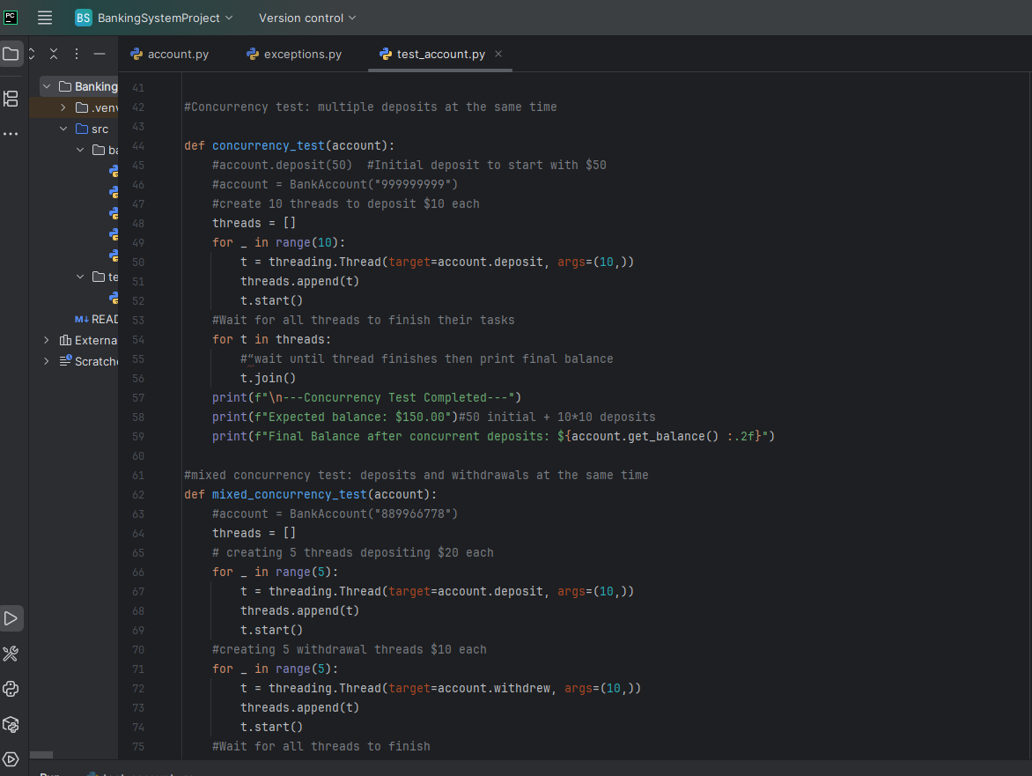

Appendix - A Continued
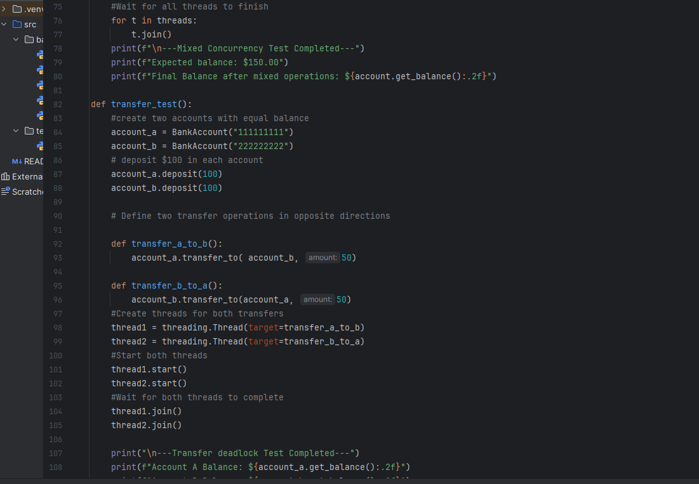
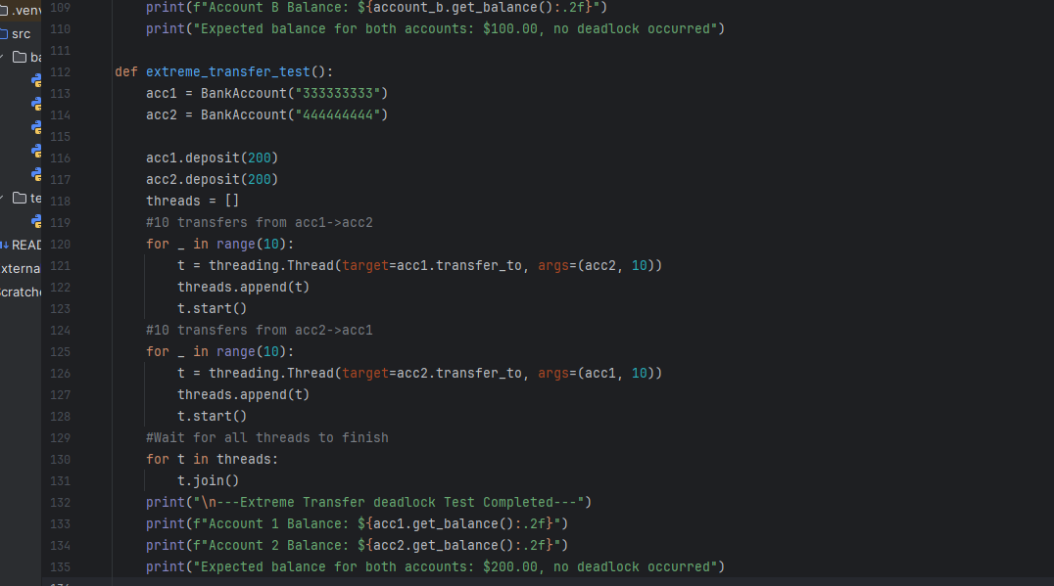

Appendix B – account.py screenshot
GitHub link account.py: https://github.com/pg25304/BankingSystemProject/blob/main/src/bank/account.py
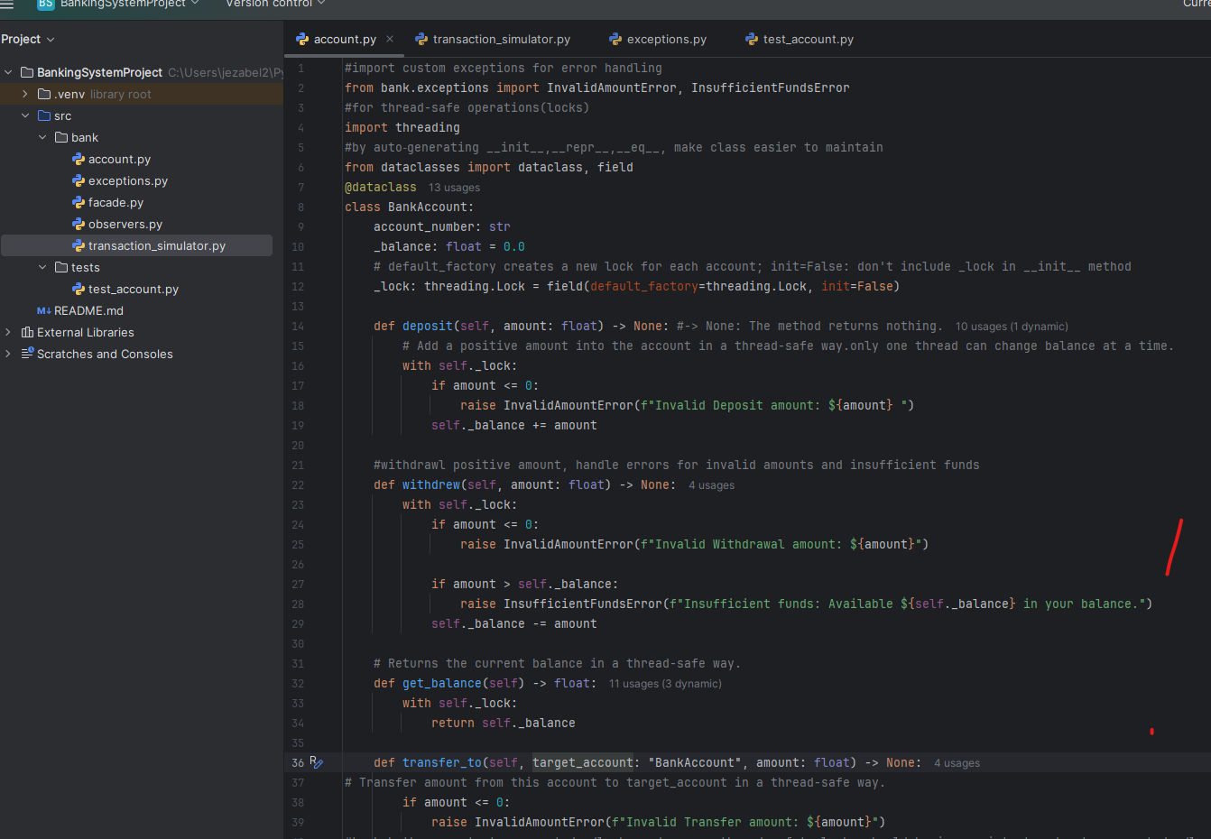
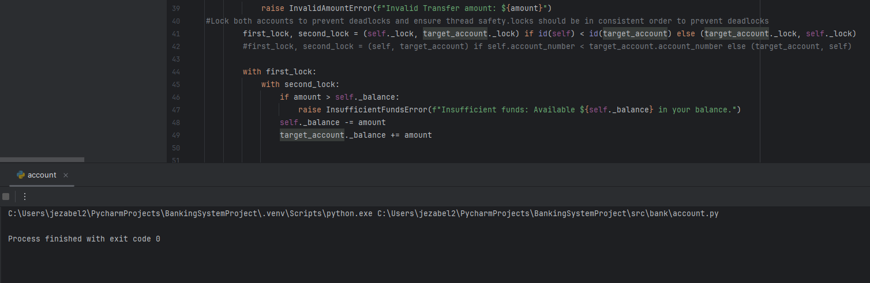

Appendix C – Screenshot of transaction_simulator.py
GitHub Link: https://github.com/pg25304/BankingSystemProject/blob/main/src/bank/transaction_simulator.py
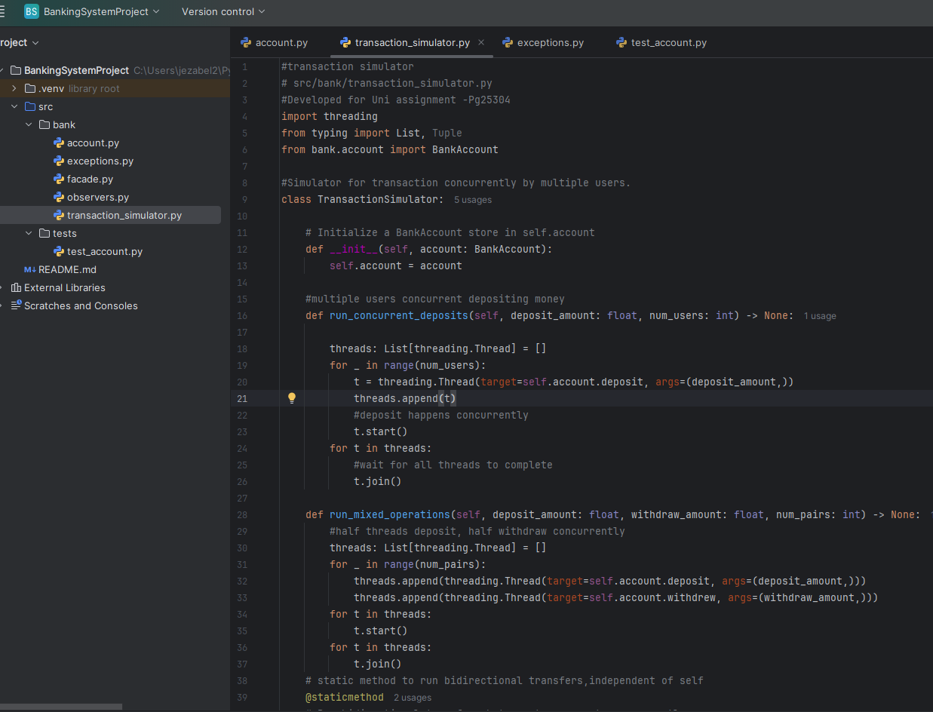
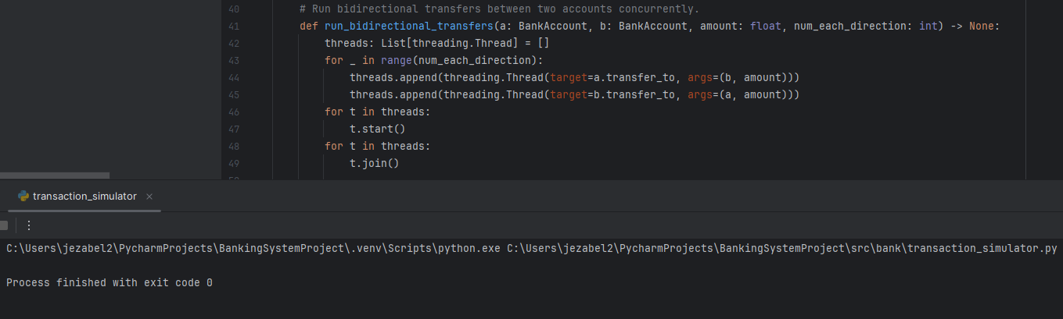

Appendix D – Screenshot of test_account.py
GitHub Link: https://github.com/pg25304/BankingSystemProject/blob/main/src/tests/test_account.py
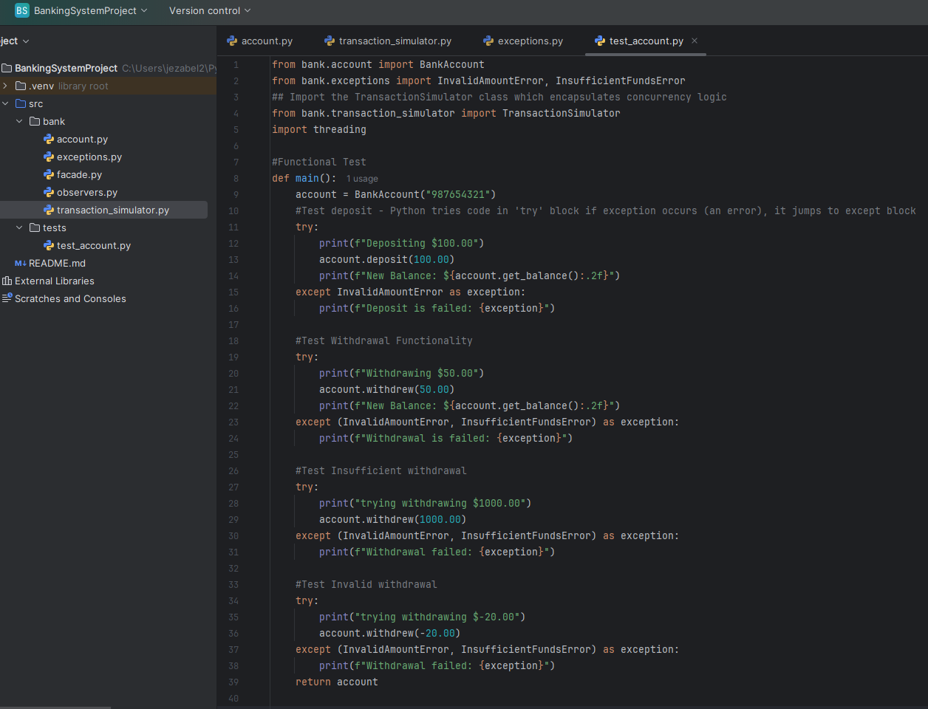

Appendix D – Continued
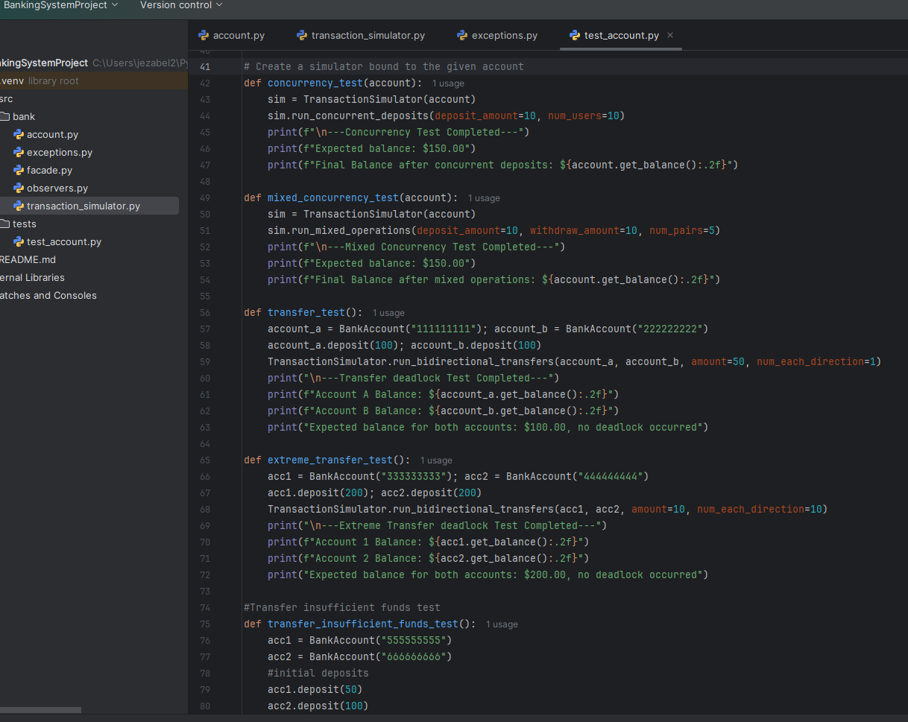

Appendix E – Result of Execution of test_account.py on PyCharm
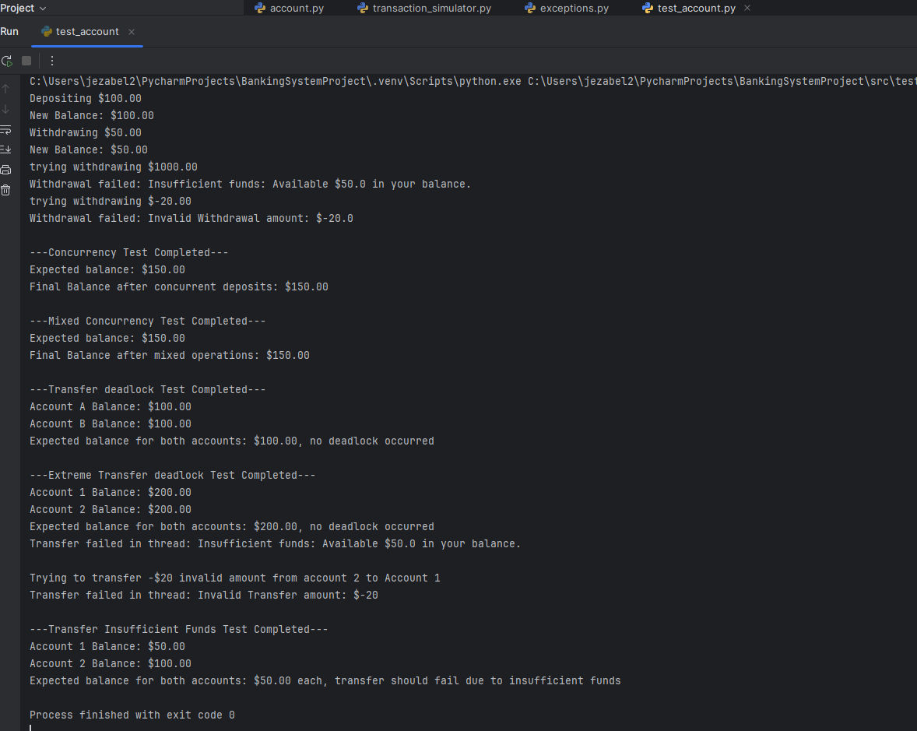

Appendix F – Screenshot of exceptions.py
GitHub Link: https://github.com/pg25304/BankingSystemProject/blob/main/src/bank/exceptions.py
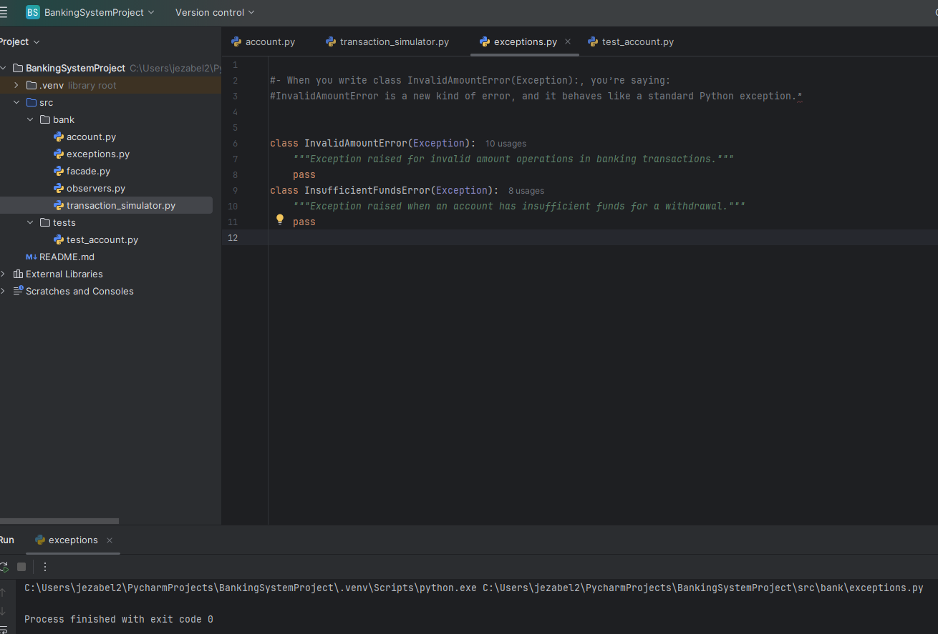

Appendix G – Screenshot of Test_Summary_Result.xlsx
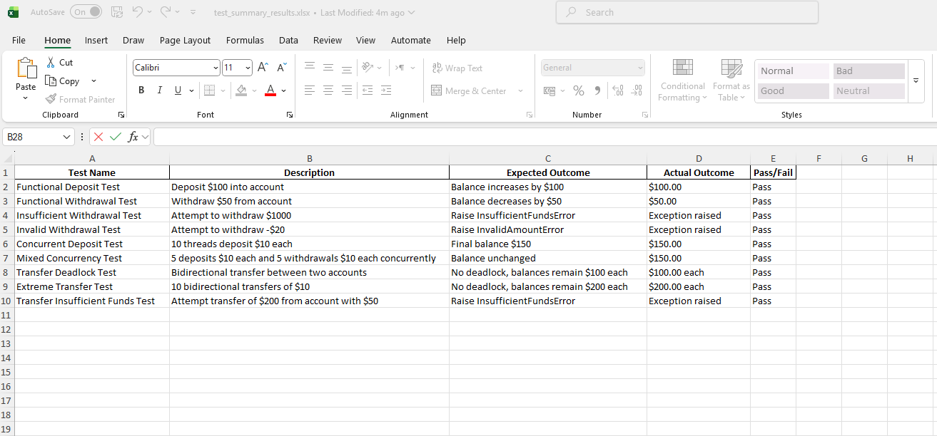

Appendix H- Screenshot of observers.py
GitHub Link: https://github.com/pg25304/BankingSystemProject/blob/main/src/bank/observers.py
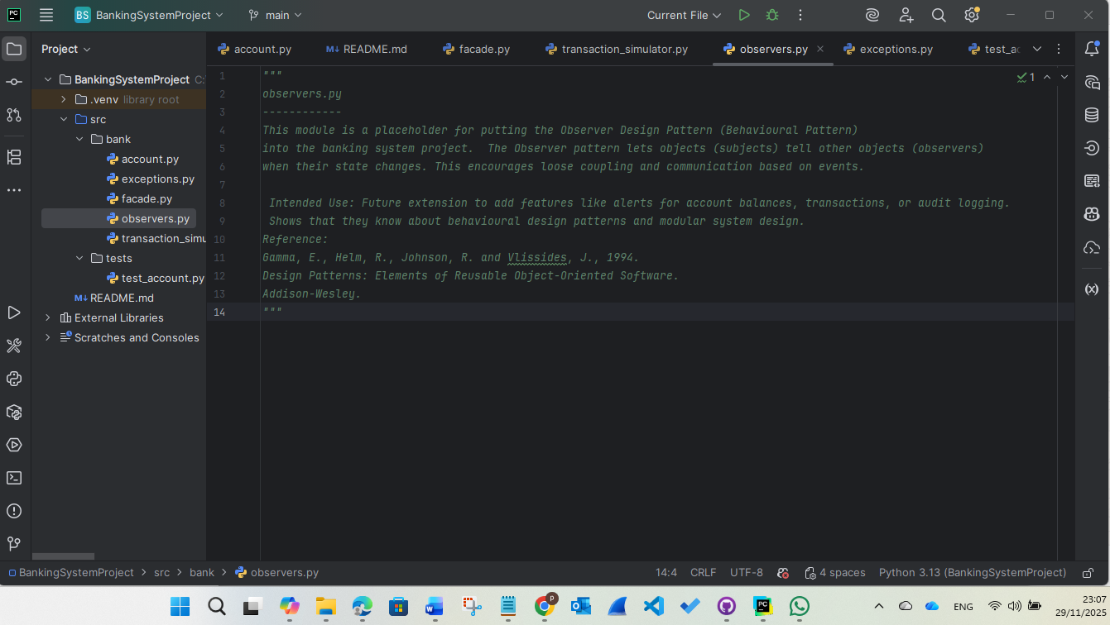

Appendix I – Screenshot of façade.py
GitHub Link: https://github.com/pg25304/BankingSystemProject/blob/main/src/bank/facade.py
